Financial Transparency
Tahaddi is built around long-term programs, not short-term projects. This means children and families continue receiving support even when individual grants end, ensuring stability in education, healthcare, psychosocial support, and livelihoods.
At Tahaddi, support doesn’t come with an expiry date.

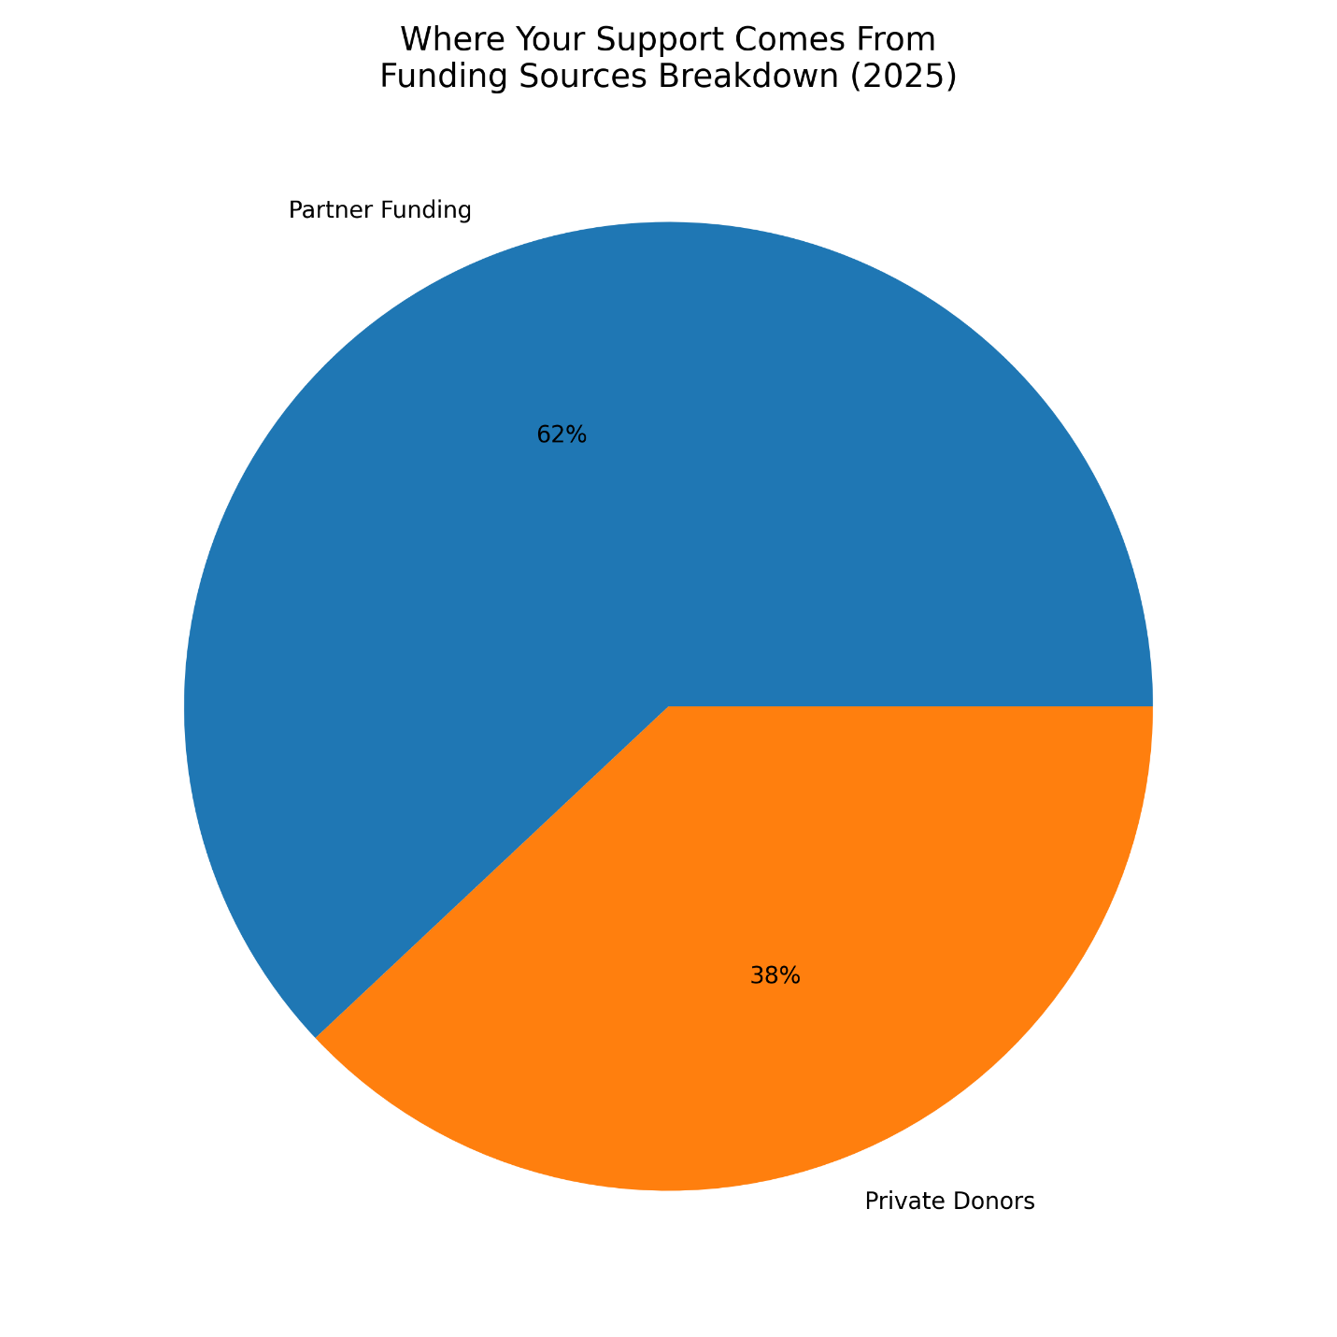
Image Title: Where Your Support Comes From – 2025 Funding Sources
Caption: Distribution of funding between institutional partners and private donors in 2025.

Five-Year Budget Overview (2021–2025)
Tahaddi has maintained consistent operational capacity despite fluctuations in Lebanon’s economic and funding environment.
Over the past five years, the organization has adapted strategically to external funding shifts while preserving program continuity. During funding contractions, accumulated reserves were responsibly utilized to ensure uninterrupted service delivery without incurring structural debt.
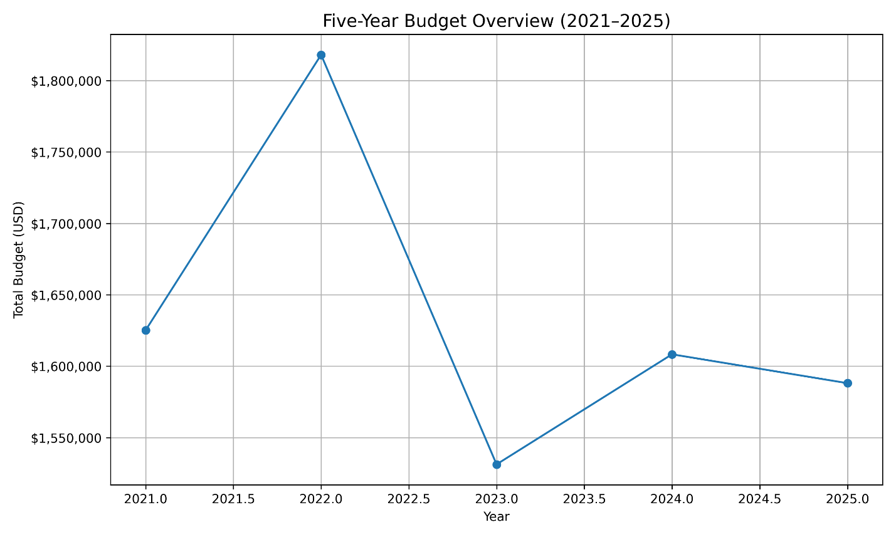
Image Title: Five-Year Budget Overview (2021–2025)
Caption: Annual budget trend reflecting financial stability and strategic reserve management.
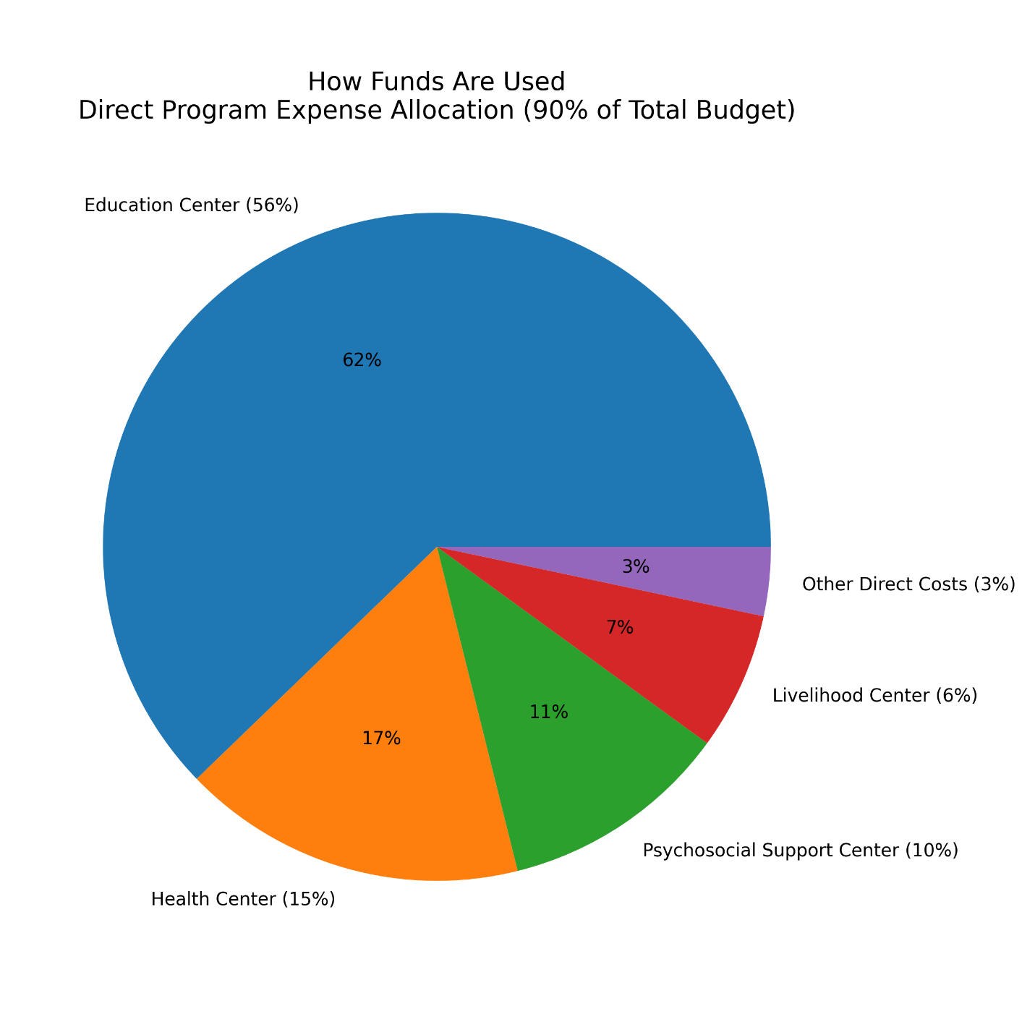
Image Title: How Funds Are Used – 2025 Expense Allocation
Caption: Distribution of direct program expenses across Tahaddi’s operational centers.

